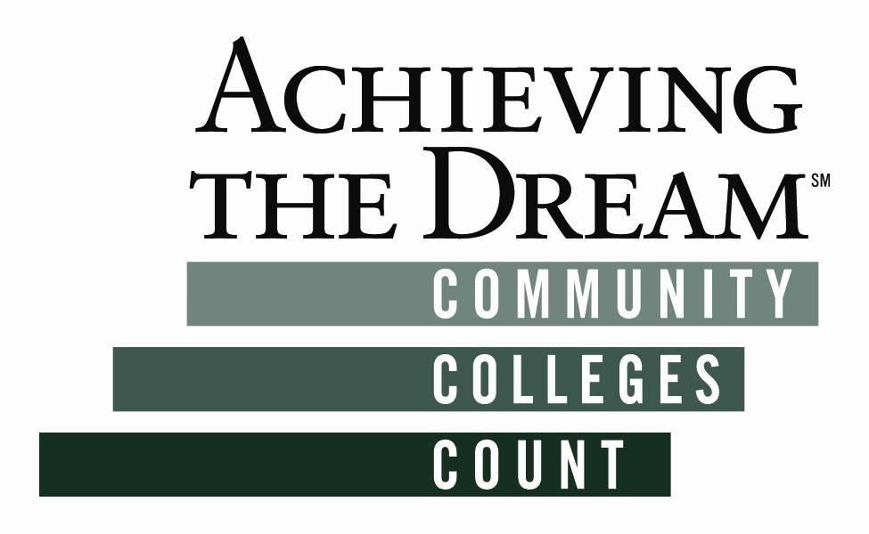
From: Lida Rafia, Associate Dean of Student Success and Equity
Tate Hurvitz, Academic Senate President
Prepared For: Achieve the Dream (ATD) Planning Committee, 12/11/2015

GROSSMONT COLLEGE CAMPUS WIDE ALIGNMENT EFFORTS:
HIGH-LEVERAGE LIST 4th DRAFT
 | Outreach  (i.e., high school, community, international,  business,  partnerships, recruitment) | Onboarding (i.e., orientation, assessment,  degree maps, Ed. Plans) | College  Prep  (i.e., curriculum alignment, summer bridge) | Student Engagement  (i.e., in-class strategies, college culture, Community Service Learning) | Program Interventions (i.e., mentoring, supplemental instruction) | Course Interventions (i.e., Learning Communities, Acceleration, integrative learning, faculty professional development)
Student Success  & Support  Program (SSSP)  Contact:  Martha Clavelle |  | orientation; assessment; abbreviated and comprehensive education and other planning to all currently enrolled students | group and individual experiences for students needing assistance with identifying academic goal/course of study/ academic pathway |  | follow-up services to at-risk students (basic skills students, students on or at risk of academic probation, and students without defined education goals)
Student  Equity  Contact:  Lida Rafia | comprehensive outreach; focused outreach in nursing, including males and students of color; Latino/a Parent Night; partner with San Diego Center for Ethics in Science and Technology; outreach to undocumented population and non-CAFYES qualifying foster youth; work with Guardian Scholars to develop outreach to foster youth students | Open House with multilingual application workshops, specialized presentations for undocumented students, Latino/a students, former foster youth (FFY), refugees, etc.; improve college website; educational Safe Zone and other planning for undocumented students and non-CAFYES qualifying foster youth; multilingual application workshops; | summer bridge program—6 wk. English reading and college & career success course with weekly activities, i.e., social gatherings, workshops, and field trips | Student Engagement Center; student-led programming; Community Service Learning; Campus Cultural Events (Black History Month, Latino/a Heritage Month, National Coming Out Day); Multicultural and Rainbow graduation; retreats; institute Student Equity Hour; professional development on student engagement and equity pedagogy; Safe Zone Training; field trips; disaggregating data to ensure engagement of at-risk populations | reinstitute PUENTE; institute MESA (Math, Engineering, Science Achievement); expand Umoja-ECS (Ensuring College Success); comprehensive adult Re-Entry Program; services for undocumented students; direct student support for African American students in Nursing program; expand service hours in child development; multilingual financial aid workshops; embedded tutors for basic skills and ESL; focused financial aid for at-risk populations, including non-CAFYES qualifying foster youth | professional development for Acceleration, FTLI (Freshman Transition Leadership Institute), and M2C3 (Minority Male Community College Collaborative), ACE (Academy for College Excellence); comprehensive retention program, includes Early Alert systems; embedded librarian in target courses; curriculum development for underserved and at-risk populations; ESL linked courses; Reading Apprenticeship Training; Faculty Teaching and Learning Institute
Basic  Skills  Contact:  Beth Kelly | student focus groups | reading diagnostic test; English pre-assessment workshops; Accuplacer prep workshops | EOPS Summer Institute, student focus groups | Umoja student ambassadors; PUENTE pathway; contextualized integrated learning assignments; student focus groups; embedded counseling | Umoja tutoring; Math study center tutors; ESL, Math & English embedded tutors; tutor tracking system; student focus groups | English linked pathways; student focus groups; embedded counseling
 | Outreach | Onboarding | College  Prep | Student Engagement | Program Interventions | Course Interventions
“Via Rápida!”:  Title V  Grant  Contacts:  Chris Hill  Sydney Brown  Natalie Ray | low income & Latino/a  students; new Latino/a students; presentations & materials in Spanish; hire/train outreach staff and promotores; high schools, churches, community centers; bilingual classified staff to reach out to Latino/a students on campus; launch a website | culturally inclusive orientation and activities program for students, parents and family; in-person Student Success Day; online career exploration modules | multiple measures; assessment prep: 3-week summer boot camp, online modules, in-person seminars, hybrid options, workshop4 | culturally relevant teaching and learning; First Year Experience (FYE) program; Activities Scorecard; orientation activities; contextualized learning; range of Engagement Activities, i.e., cohort study groups, peer mentoring, Community Service Learning | peer mentoring; counseling; First Year Seminar course as foundation for learning communities and place for Mindset Interventions; faculty/staff/community mentors for 2nd year students; Just-in-Time tutoring in LTRC; division-based student study centers & tutoring workshops | Accelerated developmental English and math courses; embedded tutors; Learning Communities; online and hybrid teaching and learning
Foster  Youth  Contact:  Mario Chacon | Foster Youth (FY) outreach conducted at feeder high schools (East County Alliance), independent living centers and other locations and events coordinated with SD County Dept. of Social Services and other FY advocacy programs (i.e. College Connection Advisory Council, Promises 2 Kids, etc.); Guardian Scholars program outreach; SDSU | population specific orientations for EOPS eligible FY, which will also comprise financial aid and Guardian Scholars program participation components; priority financial aid application processing; individual degree mapping and educational planning | FY students transitioning from high school encouraged to participate in CAFYES and the EOPS Summer Institute Program (SIP); backpacks and school supplies provided to Guardian Scholars program students; select CAFYES participants will participate in a Summer Bridge experience at SDSU | culturally relevant teaching and learning for FY students in EOPS SIP; field trips & events for Guardian Scholars/CAFYES students; leadership training opportunities for student mentors | ongoing personal, academic and career counseling; mandatory course progress reports; student mentoring; life-skills workshops; tutoring for FY students; Financial Aid snack bar and EOPS meal cards for Guardian Scholars students; key services will also be provided to CAFYES and CARE program eligible FY single parent students; qualifying CAFYES students will also participate in professional mentoring activities, and receive Mental Health Support | CAFYES students will receive basic skills course tutoring support on an ongoing basis
East  County Alliance  Contact: | Grossmont Union High School District collaboration and outreach; launch comprehensive website; parent workforce engagement; ambassadors; The Promise | inform students about college and career options; raise scholarship funds for students who commit to goals that prepare them for college or a career | college readiness; curriculum alignment in English & math, extend to other subjects and areas; raise scholarship funds for students who commit to goals that prepare them for college/career; multiple measures; assessment prep | increase student engagement; Got Plans! College and Career Fair | increase programs allowing high school students to take college classes

